Date: 06.11.2020
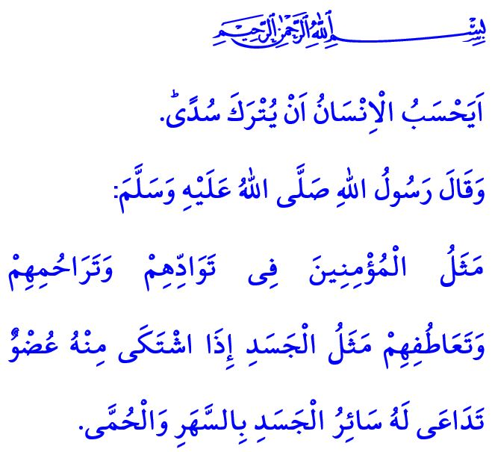
BEING RESPONSIBLE MUSLIMS
Honorable Muslims!
Allah the Almighty (swt) has created human with such attributes as having reason, being worthy of respect, and having responsibilities. Our Almighty Lord (swt) specified, among the principles of Islam, the rights that every human being has by birth and some responsibilities. He (swt) has given the glad tiding of happiness in this world and in the Hereafter for those people who observe these responsibilities, on top of which comes iman (faith).
We as Muslims are responsible, first and foremost, to our Lord Almighty, to Whom we owe all our existence. It is one of our most important duties as Muslims to believe in Him (swt) wholeheartedly, be connected to Him with love, obey Him, and duly observe His commandments and prohibitions.
After that, we have responsibilities towards ourselves and the people in our surroundings. We strive to include in our life all that is halal, fine, right and good, and stay away from all that is haram, unpleasant, wrong and evil. We know that the appreciation and consent of our Lord, as well as the peace of heart that He (swt) has entrusted to each one of us, are rested in our sense of responsibility.
Dear Believers!
The Almighty Allah (swt) states in the Holy Qur’an as follows: “Does man think that he will be left neglected?” It is clear, therefore, that a life without responsibility, thought, principles and ideals does not fit the essence of being a human. Every deed has its consequences in this world and rewards or punishment by Allah in the Hereafter.
Just as establishing prayers is a responsibility of Muslims, so too is being merciful. Just like fasting, extending a helping hand to those in need is also a human and Islamic duty. Just like giving zakat, being honest and free from fraud in all our affairs is also a duty of our servitude to Allah.
Dear Brothers and Sisters!
The Messenger of Allah (saw) describes Muslims in a hadith as follows: “The similitude of believers in regard to mutual love, affection and fellow-feeling is that of one body; when any limb of it aches, the whole body aches because of sleeplessness and fever.”
Last week we were hit by an earthquake that struck our beautiful İzmir. We kept waiting by the rubble with pain in our hearts, prayers by our tongues, and hope inside us. With the help of our Lord (swt) and the support of our state, we all were mobilized as a nation to cure our wounds.
It is naturally impossible to prevent an earthquake. Let us not forget, however, that it is a requirement of the responsibility of being a Muslim to take precautions and reduce the damage of natural disasters to minimum levels. May Allah protect our great nation against all kinds of disasters! May Allah treat our deceased brothers and sisters with mercy. May Allah grant their grieving families patience and quick recovery to the injured.
Dear Believers!
As I conclude this Friday’s khutbah, I would like to bring an issue to your attention. Next Wednesday, a sapling planting event will be held in predetermined localities across our country with the theme “Breath of the World, Breath for the Future”. In addition, at the request of our citizens who want to beautify their environment, a sapling will be granted free of charge by the provincial/district directorates of Agriculture and Forestry. I would like to take this opportunity to invite all members of our congregation of all ages to the sapling planting event that will contribute to the forestation of our heavenly homeland.

Qiyamah, 75/36.
Muslim, Birr, 66. General Directorate of Religious Services

